**Name: Abubakar Waziri**

**ID: 4220056**

**Image Processing Final Lab Exams Report**

**Report for Task 1: Dynamic Color Modification**

**1. Summary of Steps**

1. Loaded the input image (image1.png) using skimage.
2. Collected user inputs:
   1. **RGB Adjustments**: R:+50, G:-30, B:0
   2. **Color Inversion**: Yes
   3. **Brightness Scaling**: 1.5
3. Adjusted RGB channels while clipping values to ensure they remain in range [0, 1].
4. Applied color inversion (1 - pixel value).
5. Scaled image brightness by multiplying pixel values with 1.5 and clipped them again.
6. Saved the result as task1_output.png.
7. Printed the user inputs and steps using the report() function.

**2. Challenges Faced**

* Ensured pixel values remained valid after adjustments.
* Correct sequence of operations for inversion and brightness scaling.

**3. Use of AI Assistance**

* Debugged RGB adjustments and pixel clipping.
* Verified the correct order of operations.

**4. Output**

* Final image saved as: task1_output.png.

**In summary:**

I modified the colors of the input image (image1.png) based on user-defined parameters. I adjusted the RGB channel intensities, applied color inversion if selected, and scaled the image brightness using a user-provided factor. To ensure the image remained valid, I clipped all pixel values to stay within the range [0, 1]. Finally, I saved the modified image as task1_output.png and implemented a report() function to display the user inputs and the steps performed.

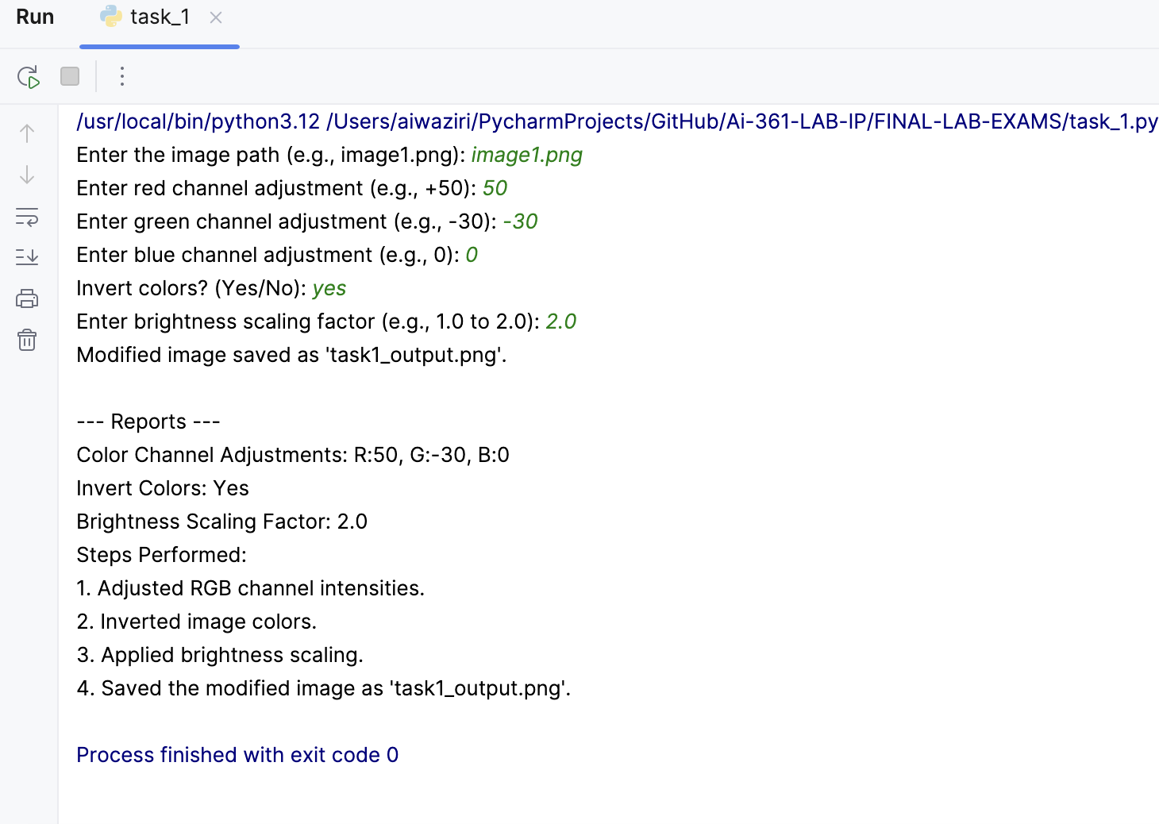

**Report for Task 2: Custom Region Enhancement**

**1. Summary of the steps**

In this task, I enhanced a user-defined region of an image by applying either a Gaussian blur or a sharpening filter. The process included extracting the region from the image, applying the selected enhancement, and blending the processed region back into the original image using a transparency factor. The following steps were performed:

• Loaded the image and obtained user inputs (region coordinates, enhancement type, and transparency level).

• Extracted the specified region and applied the enhancement (either blur or sharpen).

• Blended the enhanced region with the original image using the given transparency level.

• Saved the processed image as task2_output.png.

• Generated a report detailing the user inputs and the steps performed.

**2. Challenges Faced**

* + **Region Extraction**: Ensured the correct region was selected and extracted based on the user-defined coordinates.
  + **Processing Enhancement**: Handled both multi-channel (RGB) and single-channel (grayscale) images appropriately during enhancement.
  + **Blending the Region**: Applied transparency blending effectively to maintain the visual integrity of the original image.

**3. Use of AI Assistance**

* + Used AI to debug the Gaussian blur and sharpening function, ensuring correct handling of multi-channel images.
  + Helped with understanding the process of transparency blending and how to apply it efficiently to the image region.

**4. Output**

* + The final processed image was saved as task2_output.png.

**In summary:**

I developed a program that allows users to enhance a specific region of an image by applying either a Gaussian blur or a sharpening filter. The program first extracts the user-defined rectangular region from the image based on the given coordinates and dimensions. It then applies the selected enhancement, either by blurring the region with a Gaussian filter or sharpening it using a convolution kernel. Afterward, the enhanced region is blended back into the original image using the specified transparency level. Finally, the processed image is saved as task2_output.png, and a report detailing the steps and user inputs is generated.

Blur Example:

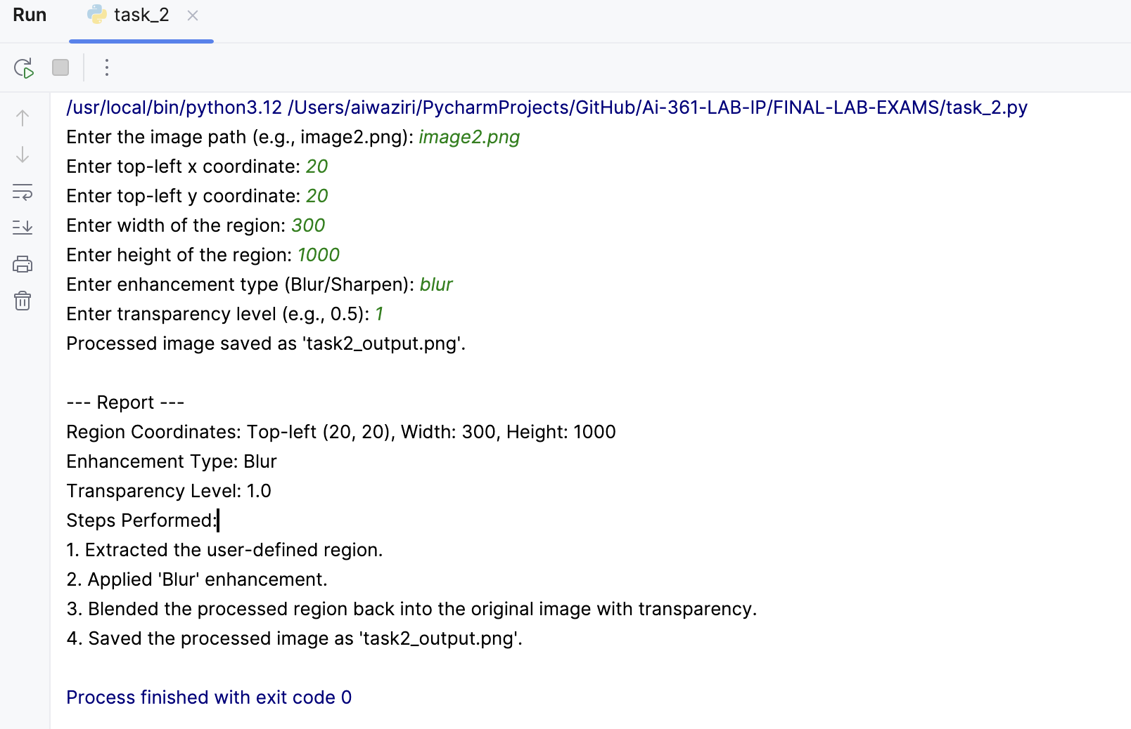

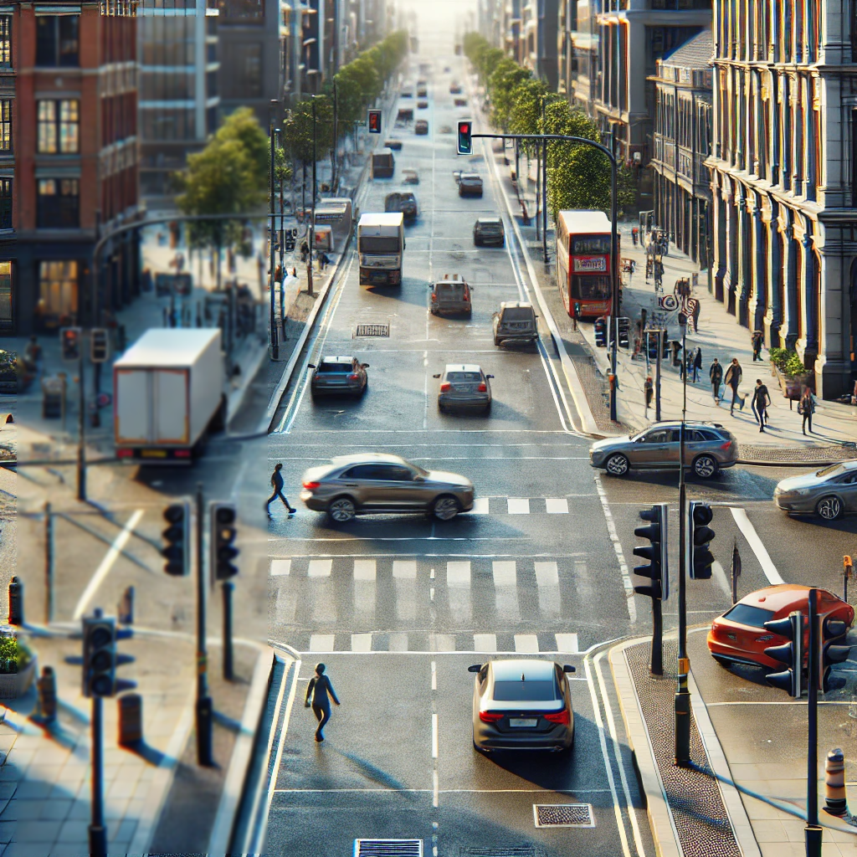

Sharpening Example:

